Create s3 bucket

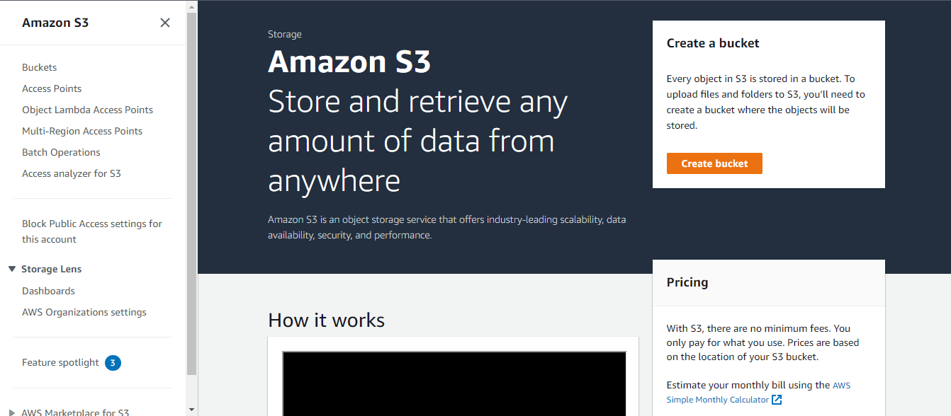

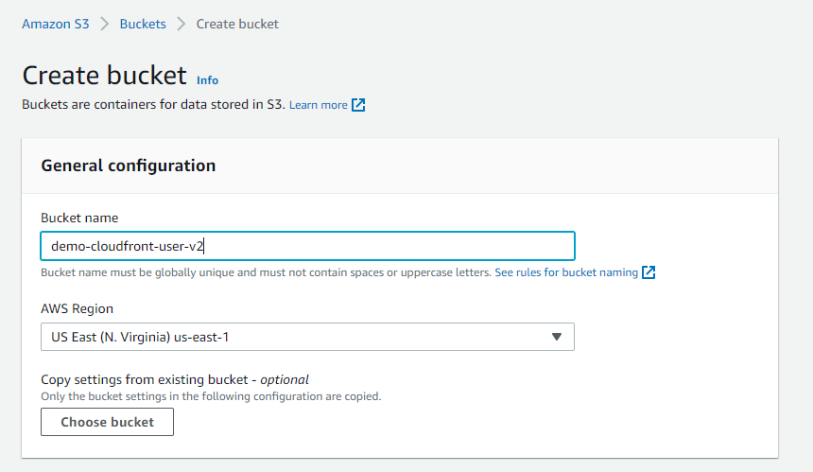

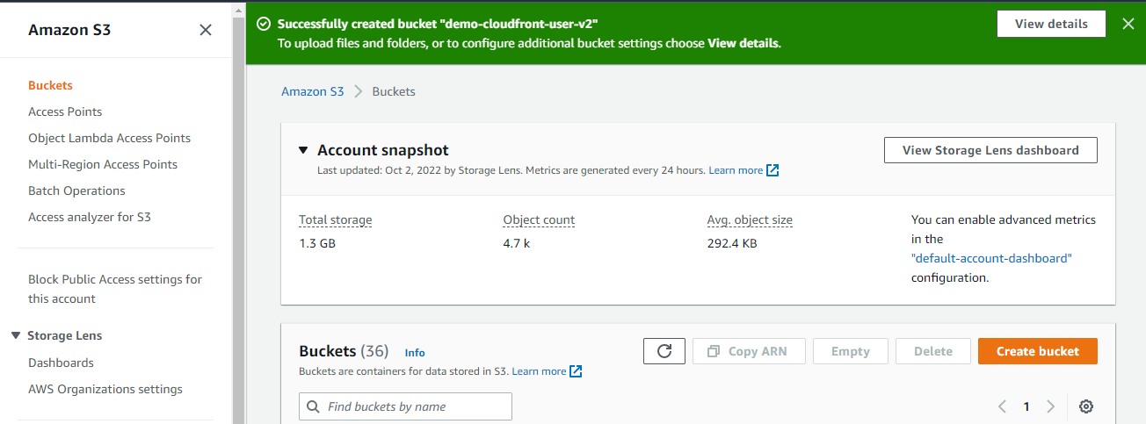

Upload files

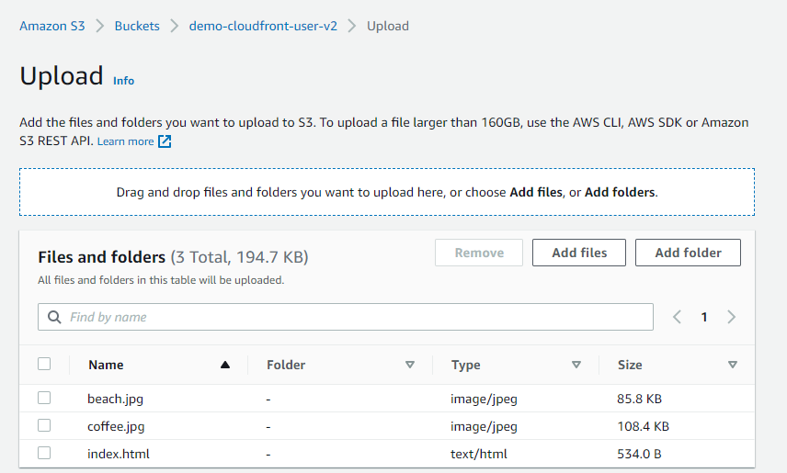

Go to Cloud Front

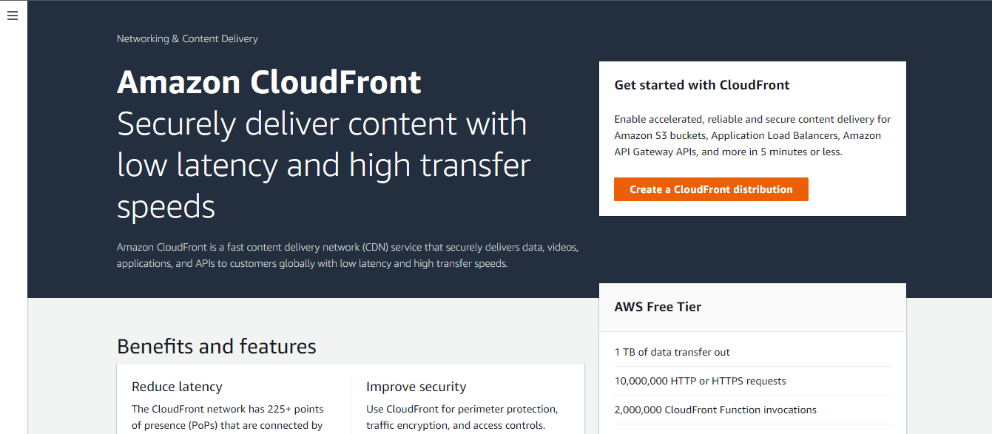

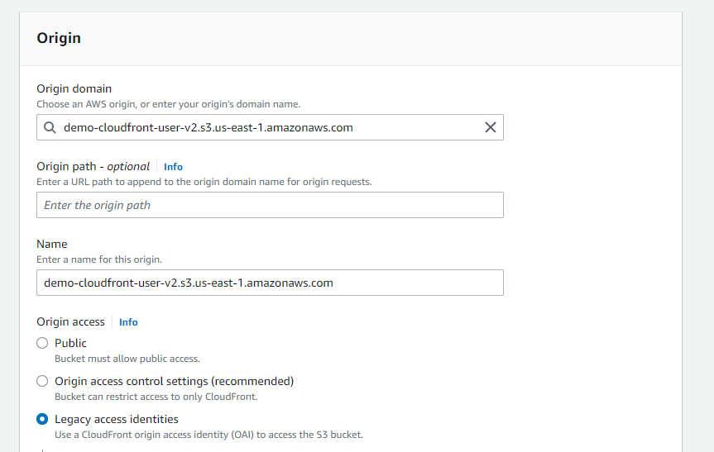

Create new OAI

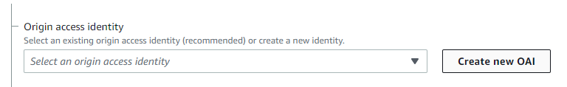

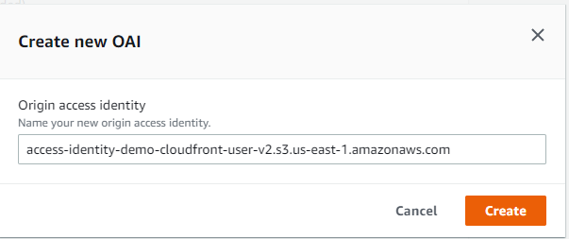

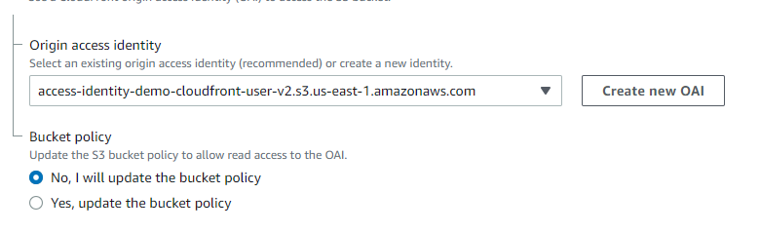

Click Yes on Bucket policy



Keep other options default

Go to settings

Default root index.html

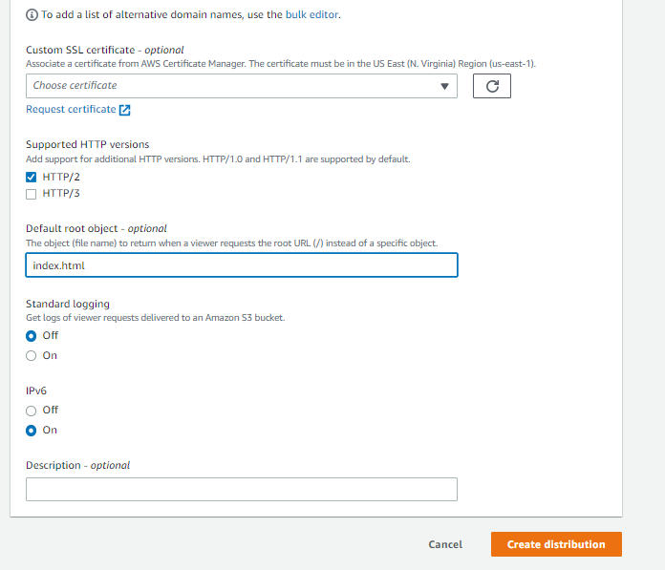

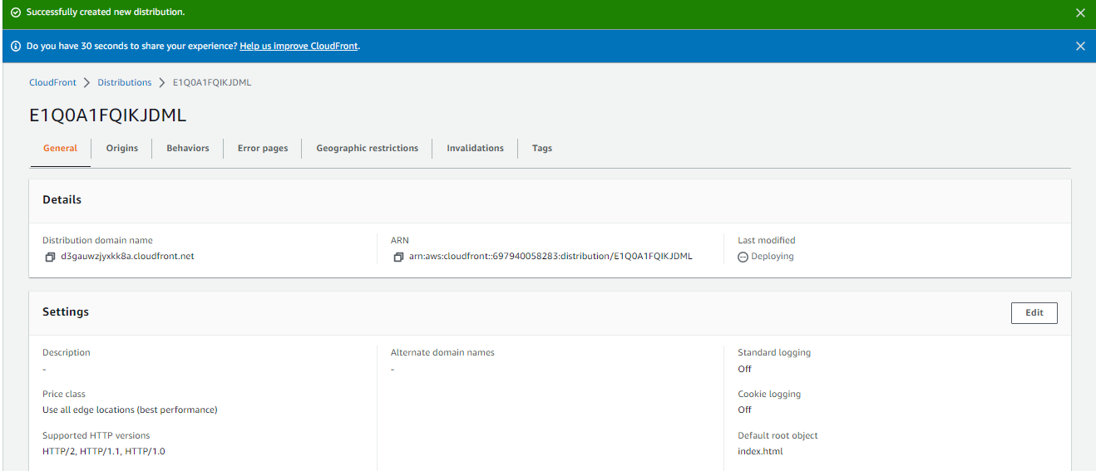

Copy distribution name

<https://d3gauwzjyxkk8a.cloudfront.net>

and paster it in new tab

you will get this result



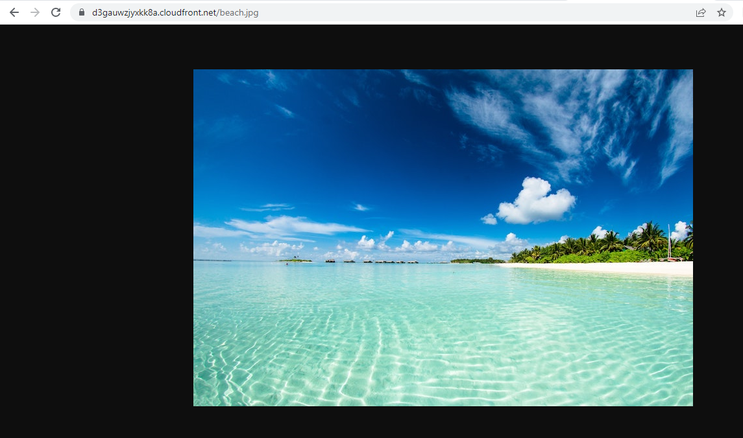





Go to s3 bucket policy

Bucket policy has been automatically filled up

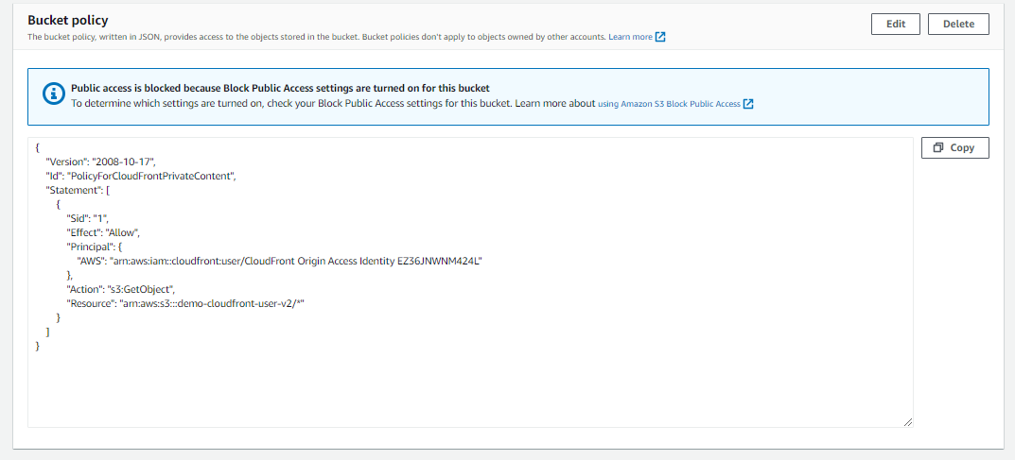

Go back to CloudFront -security-Origin access

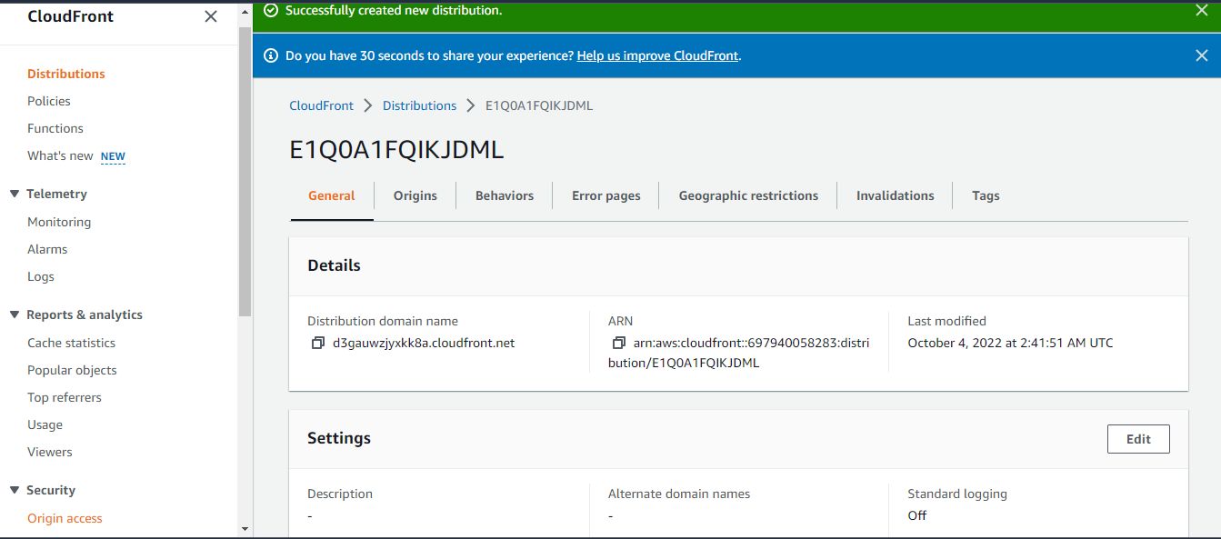

You will see ID

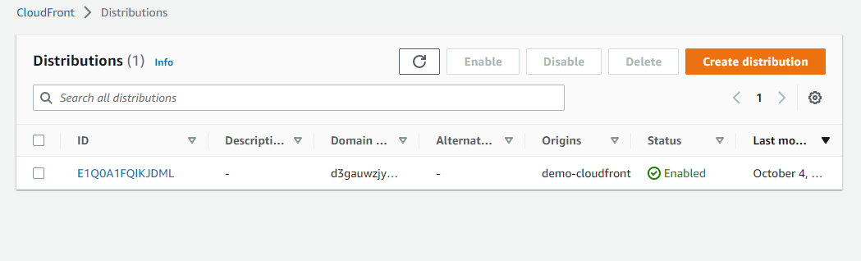

CloudFront Caching

Open CloudFront distribution ID

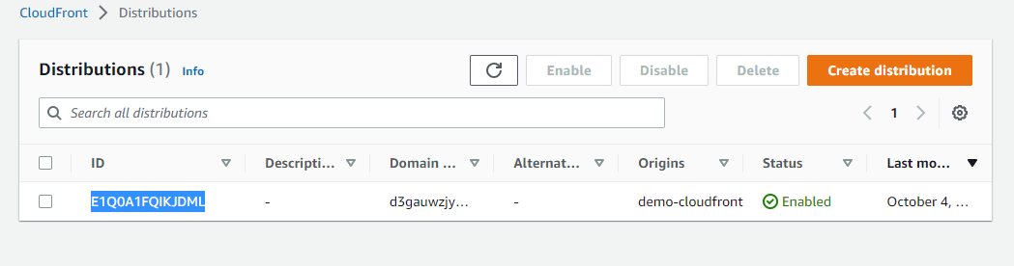

Go to behaviors and Edit CloudFront Distribution

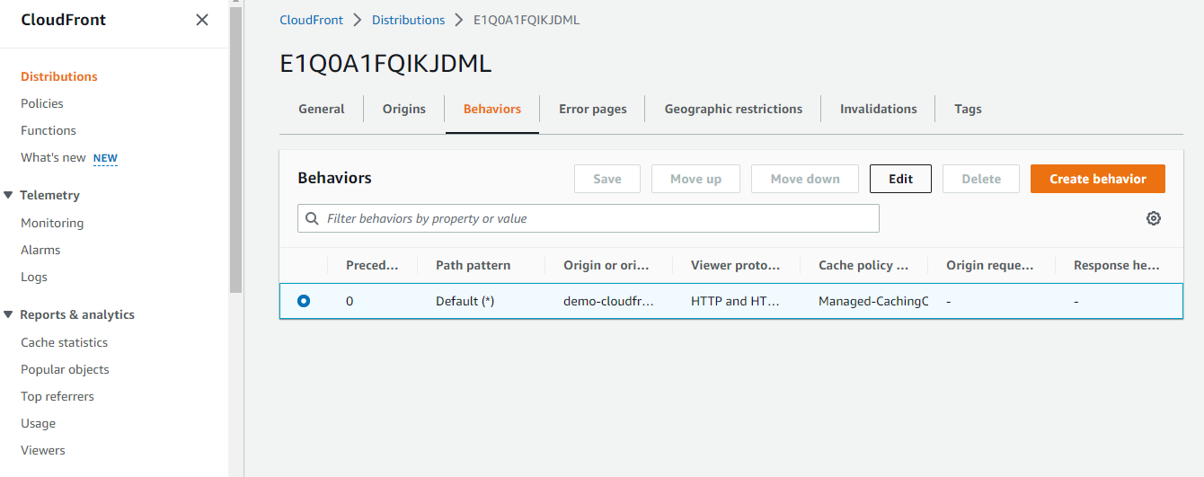

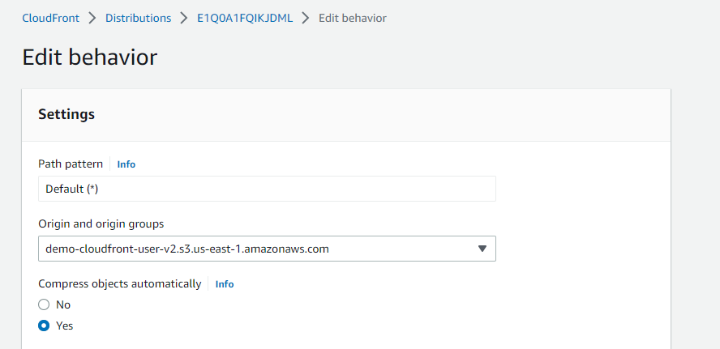

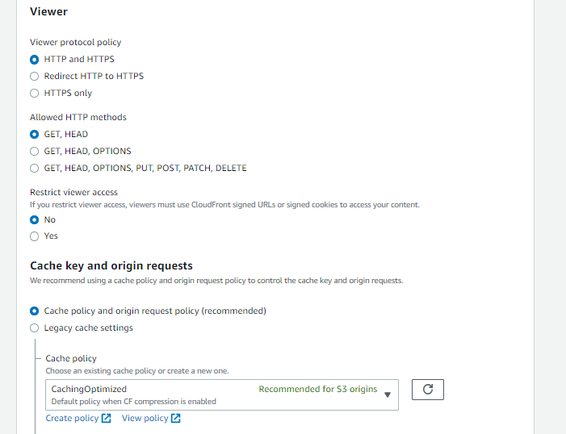

Click View Policy to see how it works

We will cancel just for demo.

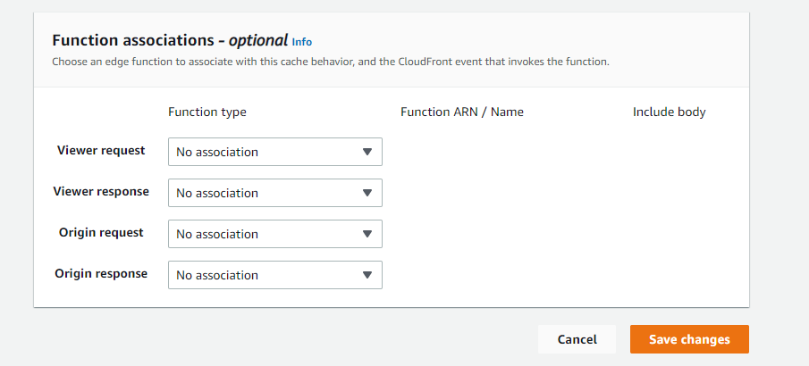

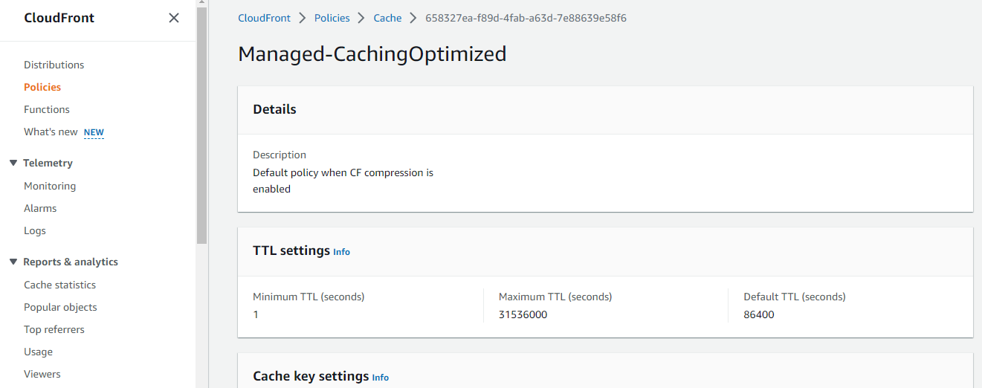

Go to CloudFront-Policies

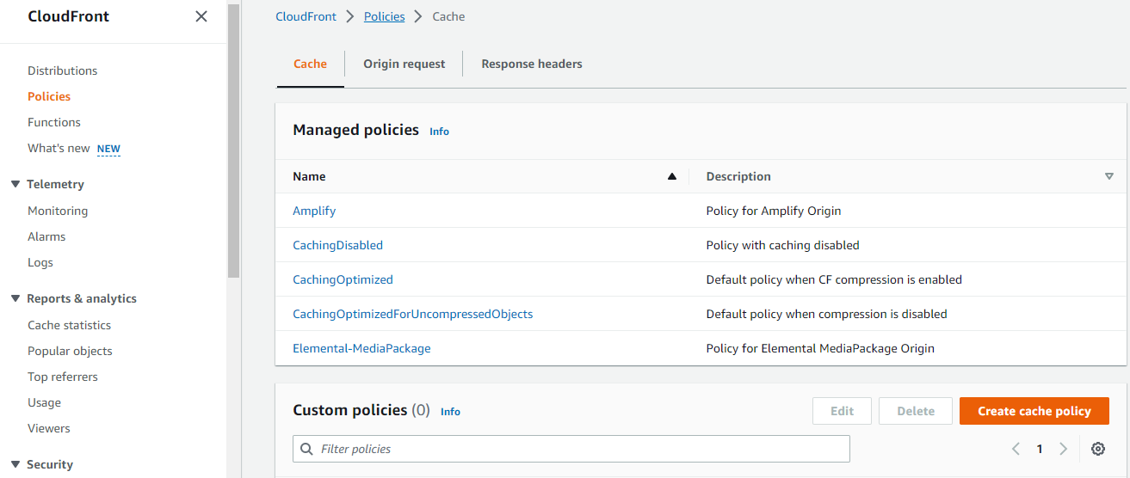

Click Create cache policy

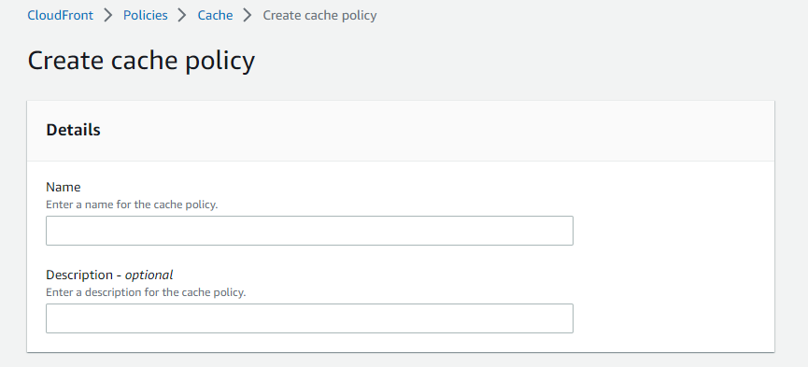

But we willnot create policy.

Now edit our index.html

<html>

    <head>

        <title>My First Webpage</title>

    </head>

    <body>

        <h1>I love coffee every morning</h1>

        <p>Hello world!</p>

    </body>

    <img src="coffee.jpg" width=500/>

    <!-- CORS demo -->

    <!-- <div id="tofetch"/>

    <script>

        var tofetch = document.getElementById("tofetch");

        fetch('extra-page.html')

        .then((response) => {

            return response.text();

        })

        .then((html) => {

            tofetch.innerHTML = html

        });

    </script> -->

</html>

And again upload file in s3 bucket.

You will get this output

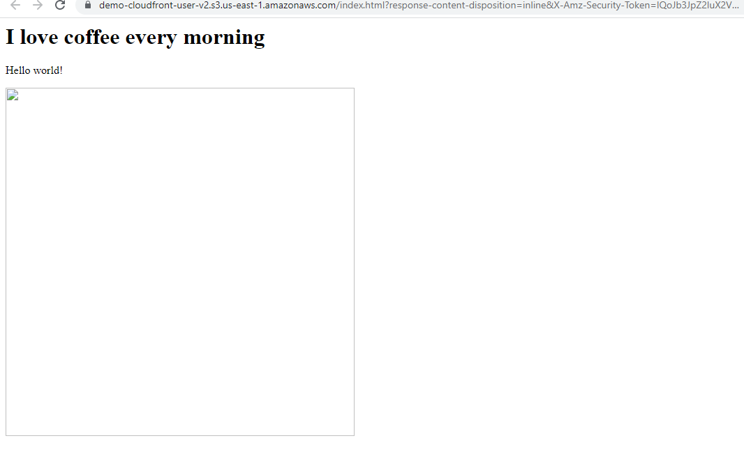

But I cloud front, we get



Go to CloudFront-Distributions-ID-Create Invalidations

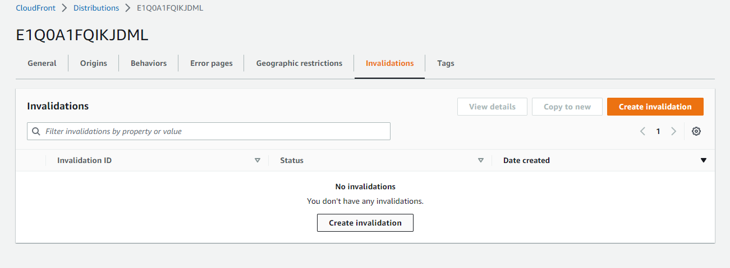

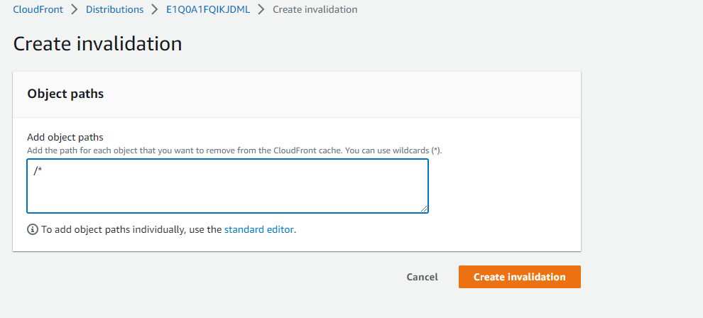

Click Create Invalidation

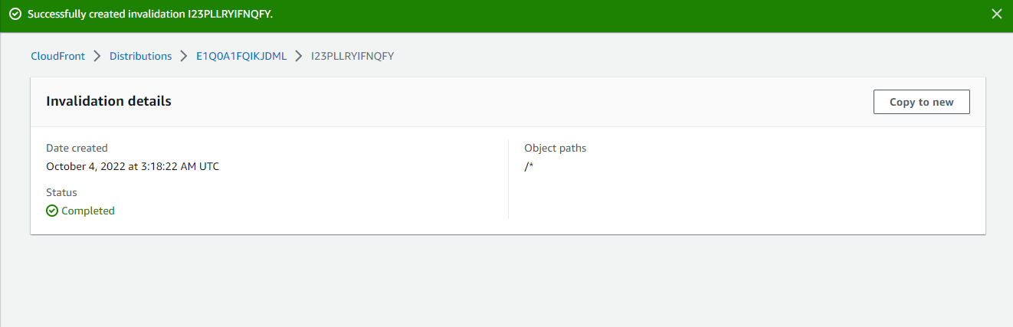

Now you will get this result in cloudfront.



**CloudFront security**

CloudFront-Distribution-Behaviors

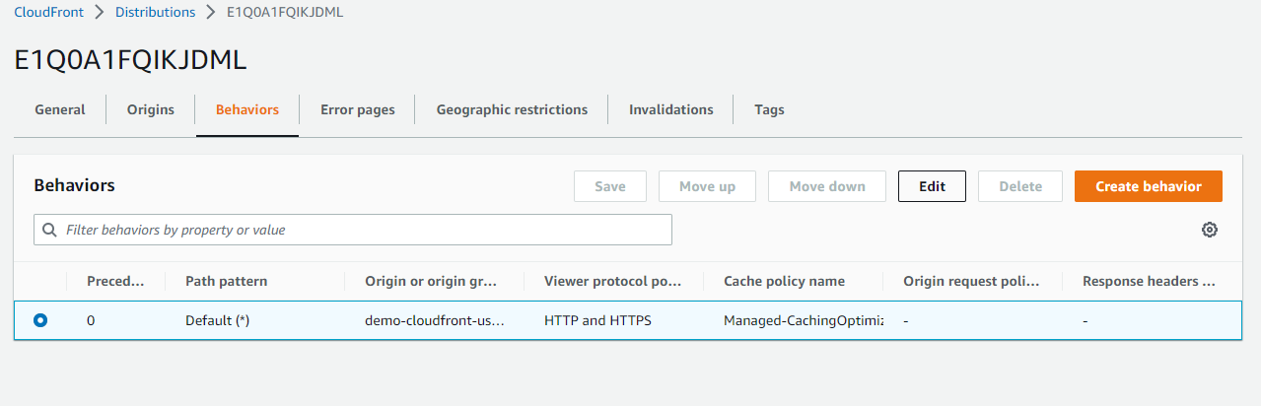

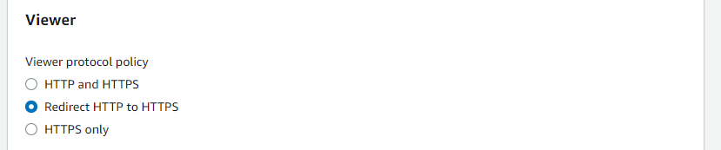

Click save changes

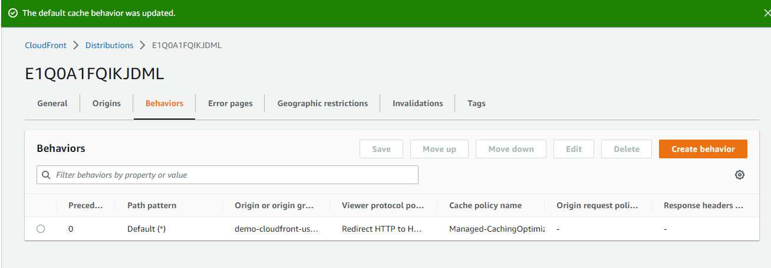

Geographic changes

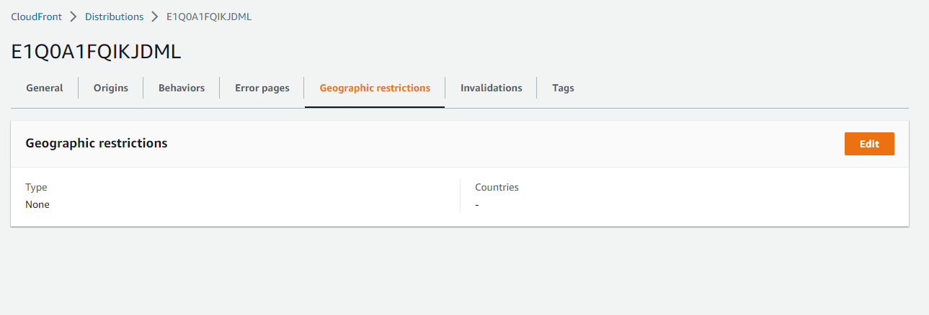

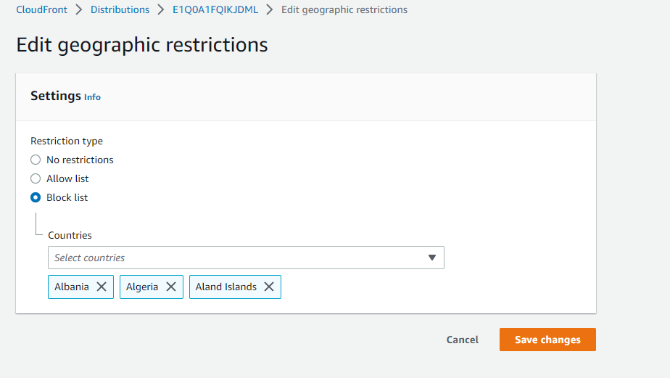

CloudFront Signed ULR Process

Cloud Front-Public keys

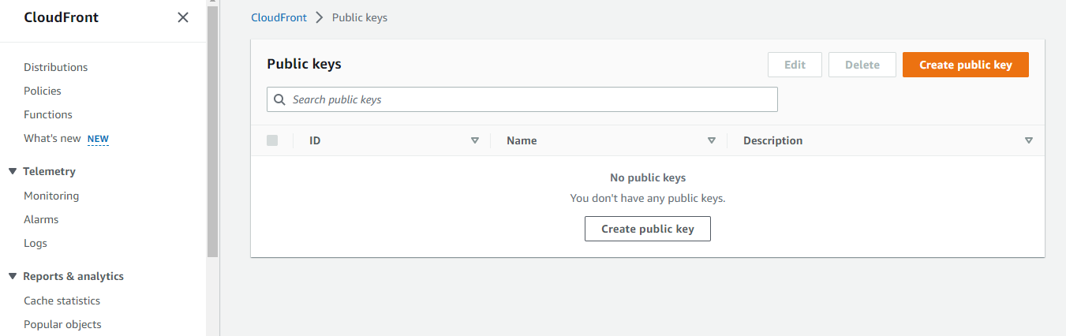

Create key 2048 bit

<https://travistidwell.com/jsencrypt/demo/>

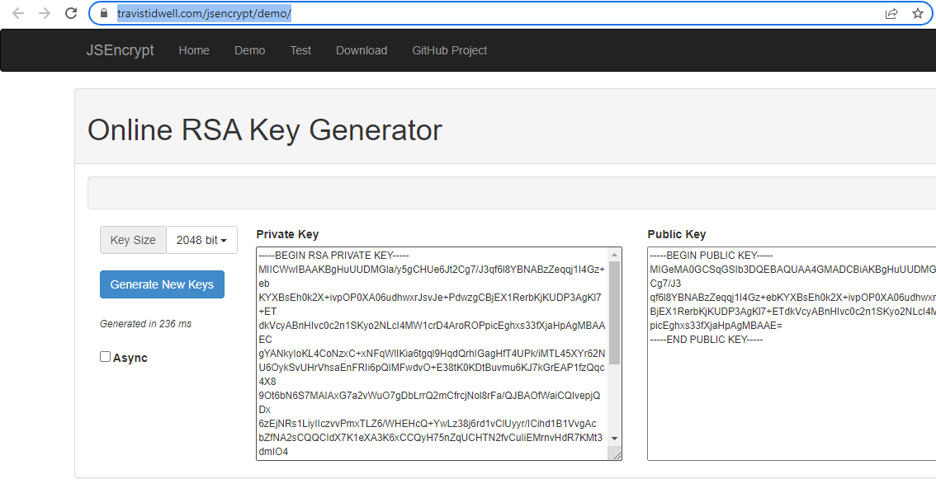

Go to CloudFront >> Public keys

Click public key

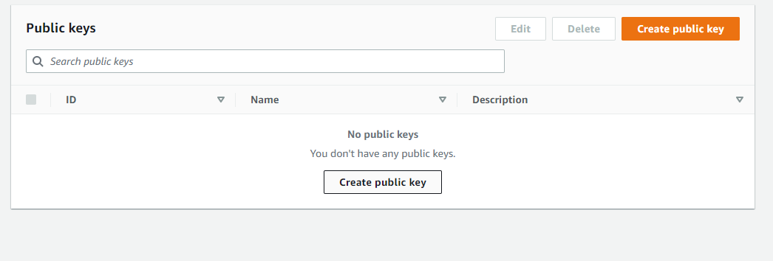

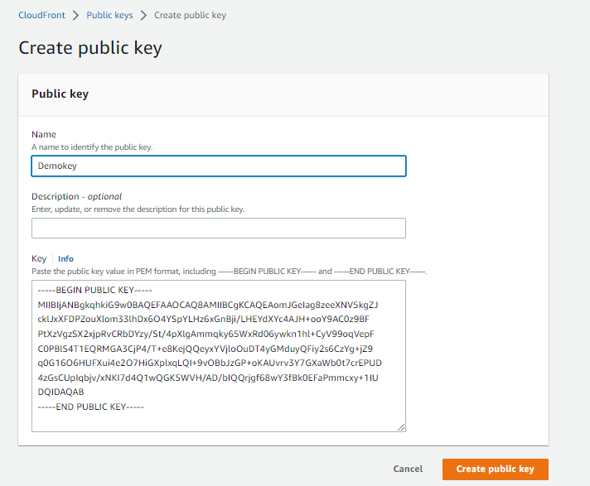

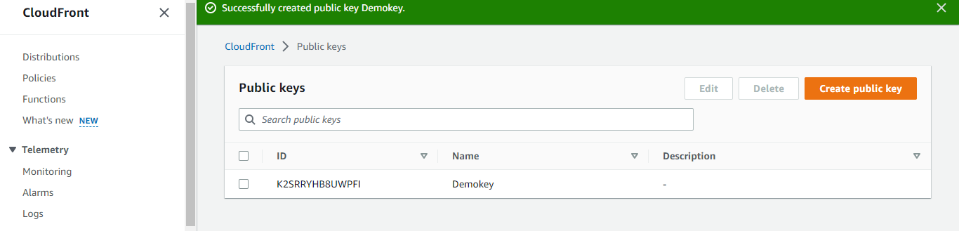

Go to CloudFront-Key group

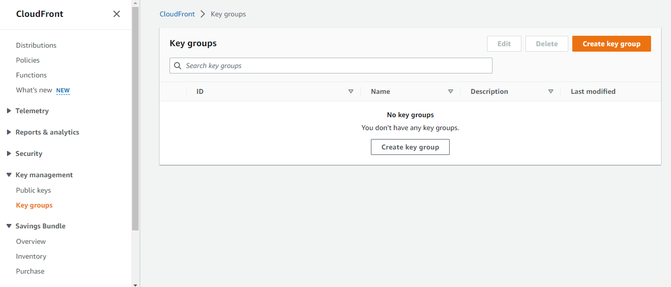

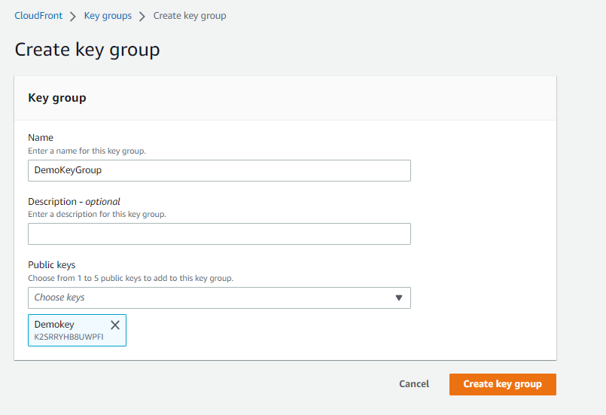

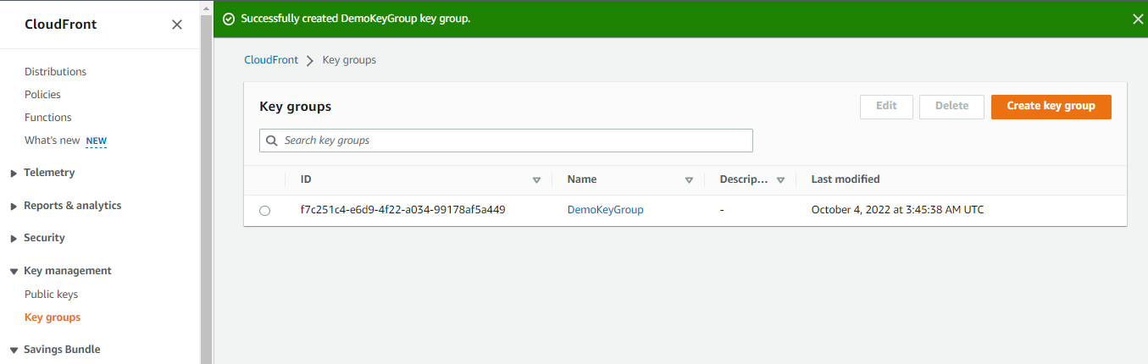

Go to root account download CloudFront key pairs public and private from IAM .

